Hands-On Lab
Lab Manual
Using Data Binding in Windows Presentation Foundation

Please do not remove this manual from the lab

Information in this document is subject to change without notice. The example companies, organizations, products, people, and events depicted herein are fictitious. No association with any real company, organization, product, person or event is intended or should be inferred. Complying with all applicable copyright laws is the responsibility of the user. Without limiting the rights under copyright, no part of this document may be reproduced, stored in or introduced into a retrieval system, or transmitted in any form or by any means (electronic, mechanical, photocopying, recording, or otherwise), or for any purpose, without the express written permission of Microsoft Corporation.

Microsoft may have patents, patent applications, trademarked, copyrights, or other intellectual property rights covering subject matter in this document. Except as expressly provided in any written license agreement from Microsoft, the furnishing of this document does not give you any license to these patents, trademarks, copyrights, or other intellectual property.

© 2005 Microsoft Corporation. All rights reserved.

Microsoft, MS-DOS, MS, Windows, Windows NT, MSDN, Active Directory, BizTalk, SQL Server, SharePoint, Outlook, PowerPoint, FrontPage, Visual Basic, Visual C++, Visual J++, Visual InterDev, Visual SourceSafe, Visual C#, Visual J#, and Visual Studio are either registered trademarks or trademarks of Microsoft Corporation in the U.S.A. and/or other countries.

Other product and company names herein may be the trademarks of their respective owners.

Contents
Lab 1: Using Data Binding in Windows Presentation Foundation 1
Lab Objective 1
Exercise 1 – Allow the user to enter an item for sale 1
Task 1 – Become familiar with the data source 2
Task 2 – Cause “Description” to update live in the preview section 3
Task 3 – Update “Current Price” when a new “Start Price” is entered 5
Task 4 – Inform the user of invalid entries 7
Task 5 – Update the preview section when selecting new values for “Category” and “Special Features” 10
Task 6 – Enable “Special Features” to certain users only 12
Exercise 2 – Allow the user to view a list of items for sale 15
Task 1 – Setup 16
Task 2 – Populate a ListBox with items and view details of the selected item 17
Task 3 – Add functionality to “Group by category” CheckBox 18
Task 4 – Add functionality to “Sort by category and date” CheckBox 20
Task 5 – Add functionality to “Show only bargains” CheckBox 22
Task 6 – Link the two exercises together. 24
Lab Summary 24

Lab 1: Using Data Binding in Windows Presentation Foundation

Any real-world scalable application relies on a data model. Data Binding is the process that connects that data with the User Interface of your application. The easy communication between the two enables us to easily achieve a very clean separation of the UI and business logic, allowing designers and developers to work in parallel doing what they do best.
Support for data has been an afterthought in many previous technologies. “Windows Presentation Foundation,” however, was designed from the ground up with Data Binding in mind. Data Binding in “Windows Presentation Foundation” is extremely flexible because developers can link any Control to any type of data.

This lab will cover the main scenarios around Data Binding. We hope this is a good starting point for you to discover more about Data Binding as you apply these concepts to your own applications.

Lab Objective
Estimated time to complete this lab: 2 hours (Exercise 1 – 1h30m, Exercise 2 – 30m)
The objective of this lab is to build an application that allows the user to view a list of items for sale and add a new item to that list. This simple scenario will familiarize you with several key Data Binding concepts.
In this lab, you will have a chance to complete the two following exercises:

- Allow the user to enter an item for sale
- Allow the user to view a list of items for sale

Note: code snapshots representing the start-point for each task in the lab are available beneath the C:\Labs\DEV010 Using Data Binding in WPF\Source folder. These may be useful if you want to begin the lab somewhere in the middle, or if your project gets into an unrecoverable state.
The Microsoft Windows Software Development Kit (SDK) has been installed on this computer, and is available by clicking the “Microsoft Windows SDK” shortcut in the Start menu. Users are encouraged to keep the SDK open during their lab experience in order to develop a deeper knowledge of relevant concepts and find answers to common questions. Application Programming Interface (API) reference documentation is also available within the SDK.

Exercise 1 – Allow the user to enter an item for sale
In this exercise you will write an application that allows the user to enter the details of an item for sale. As the seller types the information about the item, he/she will be able to see a live preview of what the product listing will look like to the buyers.

This exercise covers the following Data Binding concepts:
- The Binding object
- DataContext
- DataTemplate
- Property change notifications
- Validation (including ValidationRule and ValidationAdorner)
- Converter
- DataTrigger
- MultiBinding
- Binding to subproperties

This is what your application will look like at the end of this lab:

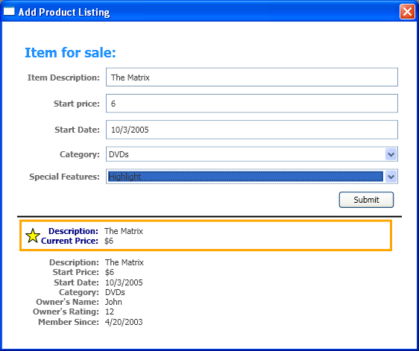

Figure 1.1 – Exercise 1 complete

Task 1 – Become familiar with the data source
- Open C:\Labs\DEV010 Using Data Binding in WPF\Source\CS\Exercise1\Task1\DataBindingLab.sln in Visual Studio. Open the AuctionItem.cs, Bid.cs and User.cs files, read the class definitions and understand how they relate to each other. “AuctionItem” represents an item that a “User” (seller) lists for sale. A “User” (buyer) can also “Bid” on an “AuctionItem”.

Task 2 – Cause “Description” to update live in the preview section
New concepts: Binding object, DataContext and DataTemplate

- Run the project. The “Add Product Listing” Window should be open at this point. You can type data in the text boxes but nothing is data bound yet. The goal for this task is to see a real time preview of the Description data in the entry form, as you type. There will be two sections in the bottom of this form that show how this data will be displayed to the buyers.

- Take a look at the file AddProductWindow.xaml, where you will find the markup for the entry form.

- We are going to use many data bindings in this exercise, each of which requires a data source. We would have to explicitly specify a data source for each binding if it wasn’t for the DataContext property, which allows us to provide a single source for all bindings within our UI. The DataContext for this Window should be a newly created AuctionItem that will later be added to a collection of AuctionItems. To set the DataContext, copy the following code to AddProductWindow.xaml.cs. (Note that in each task, the code to be added is highlighted.)

private void OnInit(object sender, RoutedEventArgs e)
{
this.DataContext = new AuctionItem("Type your description here",
ProductCategory.DVDs, 1, DateTime.Now,
((DataBindingLabApp)Application.Current).CurrentUser,
SpecialFeatures.None);
}

- In AddProductWindow.xaml, add the following event handler to the Window that will cause the DataContext to be set when the Window is loaded:

<Window x:Class="DataBindingLab.AddProductWindow"
(…)
ResizeMode="NoResize"
Loaded="OnInit"
>

- Add the following Binding to the TextBox where the user enters the “Item Description”:

<TextBox Name="DescriptionEntryForm" Grid.Row="1" Grid.Column="1"
Text="{Binding Path=Description, UpdateSourceTrigger=PropertyChanged}"
Style="{StaticResource textStyleTextBox}" Margin="8,5,0,5"/>

This Binding connects the Text property of the TextBox to the Description property (notice the “Path”) of the new AuctionItem that was set as the DataContext. The “UpdateSourceTrigger” specifies that whenever the user types a new character in the TextBox, the data source should be updated with the new value. If we didn’t set it, the data source would be updated with a new value only when the TextBox loses focus (the default value for UpdateSourceTrigger is LostFocus).

- Add the following Binding statement to the two ContentControls at the end of this same xaml file:

<ContentControl Name="ShortPreview" Grid.Row="1"
Content="{Binding}"
HorizontalAlignment="Left"/>

<ContentControl Name="LongPreview" Grid.Row="2"
Content="{Binding}"
HorizontalAlignment="Left"/>

The empty Binding causes the Content of the ContentControl to be the AuctionItem in the DataContext. We don’t need a Path because we want to bind to the whole object, not a property of that object. We don’t need a Source because we inherit the DataContext from Window.
We bind the ContentControls to the same source we’re modifying in the entry form so that we will be able to see the data change in the ContentControls as we type.

- A ContentControl simply holds content; it does not know how to display it. To be able to display data, it needs the help of a DataTemplate.

DataTemplates for a short and long preview of an AuctionItem have been defined in the resource dictionary of our Application, so that they can be used throughout the application. You can find those in file DataBindingLabApp.xaml. Notice that one of them has its DataType set to type AuctionItem, which means that it will be used by default for every control with Content of that type. The other one has a key.

In our scenario, we want the second ContentControl in AddProductWindow.xaml to use the DataTemplate with the key, which can be done with the following markup:

<ContentControl Name="ShortPreview" Grid.Row="1" Content="{Binding}"
HorizontalAlignment="Left"/>

<ContentControl Name="LongPreview" Grid.Row="2" Content="{Binding}"
ContentTemplate="{StaticResource detailsProductListingTemplate}"
HorizontalAlignment="Left"/>

We won’t specify a ContentTemplate for the first ContentControl so that it will implicitly use the typed DataTemplate.

- Now we need to hook up the Bindings inside each DataTemplate in DataBindingLabApp.xaml to the Description of the AuctionItem:

<DataTemplate DataType="{x:Type src:AuctionItem}">
(…)
<TextBlock Name="DescriptionDTDataType" Grid.Row="0" Grid.Column="2"
Text="{Binding Path=Description}"
Style="{StaticResource textStyleTextBlock}"/>
(…)
</DataTemplate>

<DataTemplate x:Key="detailsProductListingTemplate">
(…)
<TextBlock Name="DescriptionDTKey" Grid.Row="0" Grid.Column="1"
Text="{Binding Path=Description}"
Style="{StaticResource textStyleTextBlock}"/>
(…)
</DataTemplate>

- Run your application. Type something in the Description TextBox. Notice how the text in the two ContentControls updates as you type. This is what the project should look like at this point:

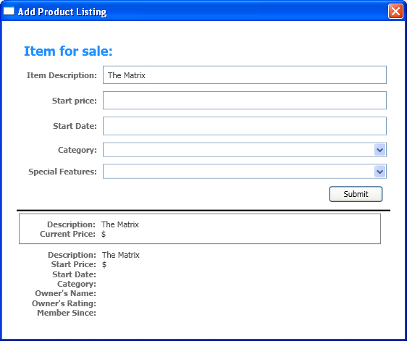
Figure 1.2 – Dependency Properties bound to the same source are kept in sync

Task 3 – Update “Current Price” when a new “Start Price” is entered
New concepts: Property change notifications

- In this task, entering the current price of the item for sale will cause the start and current prices in the preview ContentControls to update.

- First, the Text of the “Start Price” TextBox in AddProductWindow.xaml must be bound to the StartPrice property of the AuctionItem set to DataContext, just like we did in the previous task. In addition, we want to prevent the user from entering an invalid “Start Price”. This can be accomplished by adding an ExceptionValidationRule to the Binding:

<TextBox Name="StartPriceEntryForm" Grid.Row="2" Grid.Column="1"
Style="{StaticResource textStyleTextBox}" Margin="8,5,0,5">
<TextBox.Text>
<Binding Path="StartPrice" UpdateSourceTrigger="PropertyChanged">
<Binding.ValidationRules>
<ExceptionValidationRule />
</Binding.ValidationRules>
</Binding>
</TextBox.Text>
</TextBox>

- Also similar to the previous task, the DataTemplate with a key in DataBindingLabApp.xaml needs to have a Binding to the StartPrice property:

<StackPanel Grid.Row="1" Grid.Column="1" Orientation="Horizontal">
<TextBlock Text="$" Style="{StaticResource textStyleTextBlock}"/>
<TextBlock
Name="StartPriceDTKey"
Text="{Binding Path=StartPrice}"
Style="{StaticResource textStyleTextBlock}"/>
</StackPanel>

And the DataTemplate with a DataType should have a Binding to CurrentPrice:

<StackPanel Grid.Row="1" Grid.Column="2" Orientation="Horizontal">
<TextBlock Text="$" Style="{StaticResource textStyleTextBlock}"/>
<TextBlock
Name="CurrentPriceDTDataType"
Text="{Binding Path=CurrentPrice}"
Style="{StaticResource textStyleTextBlock}"/>
</StackPanel>

- Run your application. Notice that when you enter a price, the “Start Price” in the preview area will update, but the “Current Price” won’t. Look at the AuctionItem.cs file. In the setter for the StartPrice property, add the following code:

set
{
if (value < 0)
{
throw new ArgumentException("Price must be positive");
}
this.startPrice = value;
OnPropertyChanged("StartPrice");
OnPropertyChanged("CurrentPrice");
}

Notice that AuctionItem implements INotifyPropertyChanged, which requires it to have an event called PropertyChanged. Look at the OnPropertyChanged(…) method which raises that event. Notice also that the getter for CurrentPrice depends on the value of startPrice, and should therefore be recalculated when startPrice changes.

When StartPrice is set to a new value, the line of code we just added informs the data binding engine to update all Bindings that depend on CurrentPrice, in addition to those that depend on StartPrice.

- Run your application. Type a valid start price and notice how both “Start Price” and “Current Price” update in the preview area.

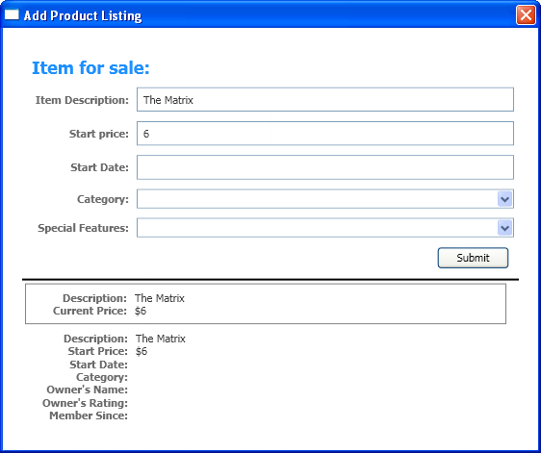

Figure 1.3 – Property change notifications inform the bindings when to refresh

Task 4 – Inform the user of invalid entries
New concepts: Validation and Converter

- At the end of this task, the user will be informed when an invalid value is entered in the “Start Price” and “Start Date” TextBoxes.

- Type some non-numeric characters in the “Start Price” TextBox. Notice that a red border is displayed around the TextBox. This is the simplest form of Validation working behind the scenes: the binding engine tries to convert the TextBox’s Text (of type string) to an integer so that it can set the StartPrice property, but the conversion fails. This causes the default Validation adorner to be displayed, which consists of a red rectangle around the control in error.

- The user is informed that there is an error but no details are given about that error. Let’s solve this problem by adding a tooltip that displays an appropriate error message. Add the following Trigger to the style for TextBox in DataBindingLabApp.xaml:

<Style x:Key="textStyleTextBox" TargetType="{x:Type TextBox}">
<Setter Property="Foreground" Value="#333333" />
<Setter Property="MaxLength" Value="40" />
<Setter Property="Width" Value="392" />
<Style.Triggers>
<Trigger Property="Validation.HasError" Value="true">
<Setter Property="ToolTip"
Value="{Binding RelativeSource={RelativeSource Self}, Path=(Validation.Errors)[0].ErrorContent}"/>
</Trigger>
</Style.Triggers>
</Style>

Both Validation.HasError and Validation.Errors are attached properties, meaning that the TextBox is able to store their values although they are defined in the Validation class. The Trigger checks the value of Validation.HasError, and if it is true it sets the ToolTip of the current TextBox to its first validation error. RelativeSource={RelativeSource Self} is a special Binding Source that refers to the current element.

Run your application. Type some letters in the “Start Price” TextBox and verify that the tooltip is displayed (move the mouse outside and over the control to see the tooltip come up).

- Binding to the StartDate is similar to what was done before. The following markup should be added to AddProductWindow.xaml. Notice that this time we’re using Object Element syntax instead of Attribute syntax.

<TextBox Name="StartDateEntryForm" Grid.Row="3" Grid.Column="1"
Style="{StaticResource textStyleTextBox}" Margin="8,5,0,5">
<TextBox.Text>
<Binding Path="StartDate" UpdateSourceTrigger="PropertyChanged">
</Binding>
</TextBox.Text>
</TextBox>

And add the following to DataBindingLabApp.xaml:

<TextBlock Name="StartDateDTKey" Grid.Row="2" Grid.Column="1"
Text="{Binding Path=StartDate}"
Style="{StaticResource textStyleTextBlock}"/>

- Run your project. The current date is displayed correctly, but with too much detail: the year, month and day are sufficient for this scenario. To fix this, we’re going to use a Binding Converter that returns a short version of the date passed. A Converter is simply a way to add custom logic to the Binding. This can be found in the DateConverter.cs file. Notice that the DateConverter is already added as a resource in DataBindingLabApp.xaml, so we can simply refer to it in AddProductWindow.xaml:

<Binding Path="StartDate" UpdateSourceTrigger="PropertyChanged"
Converter="{StaticResource dateConverter}"
>

The same should be done in the DataTemplate with a key in DataBindingLabApp.xaml:

<TextBlock Name="StartDateDTKey" Grid.Row="2" Grid.Column="1"
Text="{Binding Path=StartDate, Converter={StaticResource dateConverter}}"
Style="{StaticResource textStyleTextBlock}"/>

- Run your project. The date is now displayed as desired.

- Next we want to prevent the user from entering a “Start Date” in the past. This can be accomplished by writing a ValidationRule with that logic and referring to it in the Binding. You will find that logic in the FutureDateRule.cs file. The following markup adds the ValidationRule to the Binding in AddProductWindow.xaml:

<Binding Path="StartDate" UpdateSourceTrigger="PropertyChanged"
Converter="{StaticResource dateConverter}">
<Binding.ValidationRules>
<src:FutureDateRule />
</Binding.ValidationRules>
</Binding>

- Run your project. Notice that entering a date in the past causes the default ValidationAdorner and a tooltip with the error message to be displayed.

- Having a default ValidationAdorner is great, but in many applications the developer will want more freedom to change the appearance of the adorner. This can be done by setting the Validation.ErrorTemplate attached property in Validation to a custom ControlTemplate. ControlTemplates are used to redefine the appearance of a Control. To see this working, start by adding the following ControlTemplate to the resources in AddProductWindow.xaml:

<Window.Resources>
<src:SpecialFeaturesConverter x:Key="specialFeaturesConverter" />
<ControlTemplate x:Key="validationTemplate">
<DockPanel>
<TextBlock Foreground="Red" FontSize="20">!</TextBlock>
<AdornedElementPlaceholder/>
</DockPanel>
</ControlTemplate>
</Window.Resources>

The AdornedElementPlaceholder element is where the control being adorned is placed.

- Now set the ErrorTemplate attached property to the template that was just defined:

<TextBox Name="StartDateEntryForm" Grid.Row="3" Grid.Column="1"
Validation.ErrorTemplate="{StaticResource validationTemplate}"
Style="{StaticResource textStyleTextBox}" Margin="8,5,0,5">

- Run the application. Notice that a red exclamation mark appears to the left of the TextBox in error when you enter an invalid date or a date in the past. Notice also that a tooltip appears.

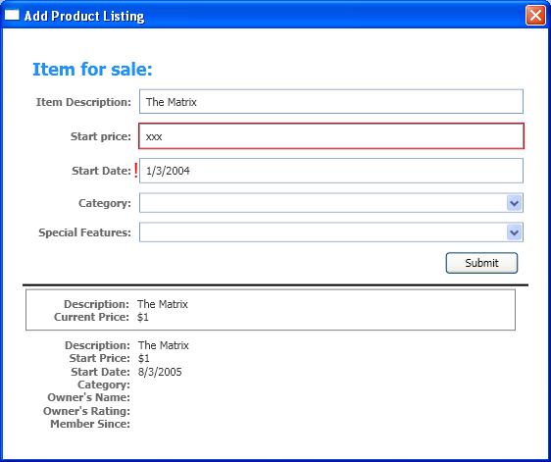

Figure 1.4 –ValidationAdorners are displayed when the user enters an invalid value.

Task 5 – Update the preview section when selecting new values for “Category” and “Special Features”
New concepts: DataTrigger

- The goal of this task is to cause the “Category” and “Special Features” entries to update the preview section when the user picks a different value in the ComboBox. “Special Features” is how the seller decides what his or her product listing is going to look like to the buyer. Different “Special Features” values will cause the short preview with the border to have a different look.

- First the SelectedValue of each ComboBox needs to be bound to the correct property of the data source. When a new value is selected by the user, this Binding will update the source with the new value. Add the following markup in AddProductWindow.xaml:

<ComboBox Name="CategoryEntryForm" Grid.Row="4" Grid.Column="1"
SelectedValue="{Binding Path=Category}"
Style="{StaticResource comboBoxStyle}"
ItemContainerStyle="{StaticResource comboBoxItemStyle}" Margin="8,5,0,5">

<ComboBox Name="SpecialFeaturesEntryForm" Grid.Row="5" Grid.Column="1"
SelectedValue="{Binding Path=SpecialFeatures}"
Style="{StaticResource comboBoxStyle}"
ItemContainerStyle="{StaticResource comboBoxItemStyle}" Margin="8,5,0,5">

- Updating the Category in the preview section is not new by now. You simply need to add the following Binding to DataBindingLabApp.xaml:

<TextBlock Name="CategoryDTKey" Grid.Row="3" Grid.Column="1"
Text="{Binding Path=Category}"
Style="{StaticResource textStyleTextBlock}"/>

- Updating the preview according to “Special Features” is a little trickier. We want to change several properties in the DataTemplate of the preview depending on the value of the “Special Features” property of the data source. The solution is to use a DataTrigger, which allows you to do just that without the need to write any code. Enter the following markup in DataBindingLabApp.xaml:

<DataTemplate DataType="{x:Type src:AuctionItem}">
<Border BorderThickness="1" BorderBrush="Gray" Padding="7" Name="border"
Margin="3" Width="500">
(…)
</Border>
<DataTemplate.Triggers>
<DataTrigger Binding="{Binding Path=SpecialFeatures}">
<DataTrigger.Value>
<src:SpecialFeatures>Color</src:SpecialFeatures>
</DataTrigger.Value>
<Setter Property="BorderBrush" Value="DodgerBlue" TargetName="border" />
<Setter Property="Foreground" Value="Navy" TargetName="descriptionTitle" />
<Setter Property="Foreground" Value="Navy" TargetName="currentPriceTitle" />
<Setter Property="BorderThickness" Value="3" TargetName="border" />
<Setter Property="Padding" Value="5" TargetName="border" />
</DataTrigger>
<DataTrigger Binding="{Binding Path=SpecialFeatures}">
<DataTrigger.Value>
<src:SpecialFeatures>Highlight</src:SpecialFeatures>
</DataTrigger.Value>
<Setter Property="BorderBrush" Value="Orange" TargetName="border" />
<Setter Property="Foreground" Value="Navy" TargetName="descriptionTitle" />
<Setter Property="Foreground" Value="Navy" TargetName="currentPriceTitle" />
<Setter Property="Visibility" Value="Visible" TargetName="star" />
<Setter Property="BorderThickness" Value="3" TargetName="border" />
<Setter Property="Padding" Value="5" TargetName="border" />
</DataTrigger>
</DataTemplate.Triggers>
</DataTemplate>

- Run your application. Pick a different Special Feature from the ComboBox. Notice how the preview section that has a border changes its look.

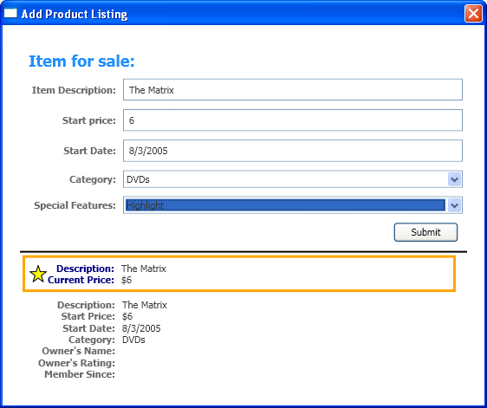

Figure 1.5 – DataTriggers change properties in the preview DataTemplate based on the “Special Features” value.

Task 6 – Enable “Special Features” to certain users only
New concepts: MultiBinding and binding to subproperties

- The goal of this task is to make “Special Features” available only to users who have a rating of 10 or greater and who have been members for over a year. The “Special Features” ComboBox should be disabled for all other users. This task will also show how to populate the extra information about the listing owner.

- Let’s start by populating the owner information. All you have to do is bind the remaining three properties in the DataTemplate in file DataBindingLabApp.xaml:

<TextBlock Name="OwnersNameDTKey" Grid.Row="4" Grid.Column="1"
Text="{Binding Path=Owner.Name}"
Style="{StaticResource textStyleTextBlock}"/>

<TextBlock Name="OwnersRatingDTKey" Grid.Row="5" Grid.Column="1"
Text="{Binding Path=Owner.Rating}"
Style="{StaticResource textStyleTextBlock}"/>

<TextBlock Name="MemberSinceDTKey" Grid.Row="6" Grid.Column="1"
Text="{Binding Path=Owner.MemberSince, Converter={StaticResource dateConverter}}"
Style="{StaticResource textStyleTextBlock}"/>

Notice that the Path syntax is different from previous examples. This syntax is necessary because in this scenario we don’t want to bind to the whole Owner object. Instead, we want to bind to subproperties of Owner. This is done by inserting a dot between the property and the subproperty.

- Next we will enable “Special Features” to certain users only depending on their rating and how long they’ve been a member. To accomplish this scenario, we need to bind the IsEnabled property of the “Special Features” ComboBox to two properties in the data source ─ the current user’s Rating and MemberSince properties ─ and add custom logic that will convert ratings and membership dates into the IsEnabled property’s type, which is Boolean. Binding to more than one property in the data source is done by using a MultiBinding. Adding custom code to a MultiBinding can be done with a MultiBindingConverter. In SpecialFeaturesConverter.cs you can find the MultiBindingConverter with the logic for this scenario.

- Add the following MultiBinding to the “Special Features” ComboBox in AddProductWindow.xaml:

<ComboBox Name="SpecialFeaturesEntryForm" Grid.Row="5" Grid.Column="1"
SelectedValue="{Binding Path=SpecialFeatures}"
Style="{StaticResource comboBoxStyle}"
ItemContainerStyle="{StaticResource comboBoxItemStyle}" Margin="8,5,0,5">
<src:SpecialFeatures>None</src:SpecialFeatures>
<src:SpecialFeatures>Color</src:SpecialFeatures>
<src:SpecialFeatures>Highlight</src:SpecialFeatures>
<ComboBox.IsEnabled>
<MultiBinding Converter="{StaticResource specialFeaturesConverter}">
<Binding Path="CurrentUser.Rating"
Source="{x:Static Application.Current}"/>
<Binding Path="CurrentUser.MemberSince"
Source="{x:Static Application.Current}"/>
</MultiBinding>
</ComboBox.IsEnabled>
</ComboBox>

You can find the CurrentUser property in DataBindingLabApp.xaml.cs. This property is instantiated in the LoadAuctionData() method, which is called in AppStartup(…). “x:Static” is the xaml syntax for setting static properties; it is equivalent to doing the following in code:

myBinding.Source = Application.Current;

- Run the project. You will see that the behavior of this project did not change. “Special Features” is still enabled. This is expected because the current user initialized in LoadAuctionData meets both requirements to have Special Features enabled, which you can confirm by looking at the Owner’s information in the preview section.

- In DataBindingLabApp.xaml.cs, change the rating of the user to be 8 instead of 12:

private void LoadAuctionData()
{
CurrentUser = new User("John", 8, new DateTime(2003, 4, 20));
(…)

- Run the project again. This time the “Special Features” ComboBox should be disabled.

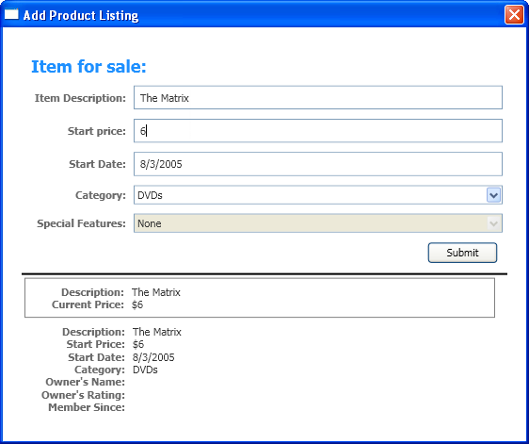

Figure 1.6 – If the user has a rating below 10, “Special Features” are disabled.

- Change current user back to having a rating of 12.

CurrentUser = new User("John", 12, new DateTime(2003, 4, 20));

- Run your project and make sure it looks similar to the image below. Congratulations, you have completed the first data binding exercise.

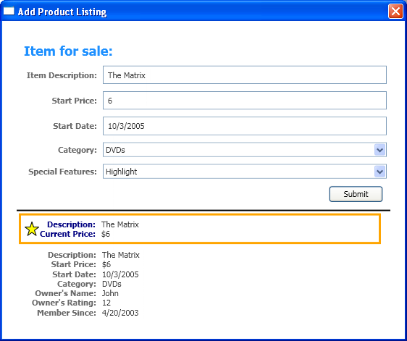

Figure 1.7 – Exercise 1 complete.

Exercise 2 – Allow the user to view a list of items for sale
In this exercise you will enable the user to browse a list of auction items for sale and find out more information about the selected item. The user will also be able to sort, group and filter the items.

You will become familiar with the following Data Binding concepts:
- Master-Detail scenario
- CollectionViewSource
- Grouping
- Sorting
- Filtering

This is what your application will look like at the end of this exercise:

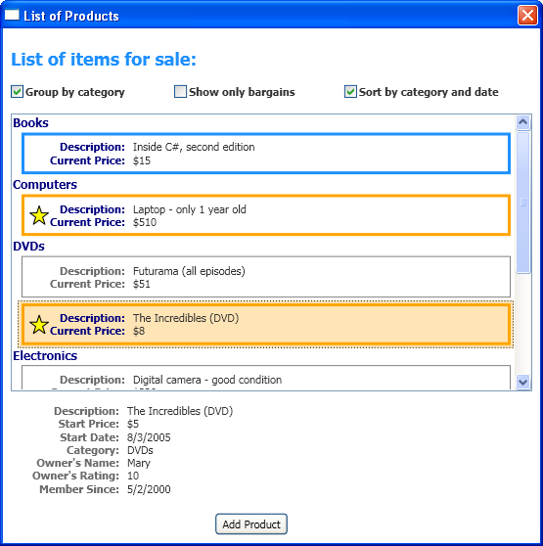

Figure 2.1 – Exercise 2 complete.

Task 1 – Setup
- In this task, you will simply change the default application to navigate to a different Window at startup.

- Switch the comments in the AppStartup(…) method in DataBindingLabApp.xaml.cs so that MainWindow is displayed when the application is started.

void AppStartup(object sender, StartupEventArgs args)
{
LoadAuctionData();
MainWindow mainWindow = new MainWindow();
mainWindow.Show();
//AddProductWindow addProductWindow = new AddProductWindow();
//addProductWindow.Show();
}

- Run the project. The Window that will contain the list of items should open.

Task 2 – Populate a ListBox with items and view details of the selected item
New concepts: Master-Detail scenario and CollectionViewSource

- At the end of this task you will have the ListBox populated with the auction items in the source collection. When the user selects an item, the item’s details will be displayed at the bottom of the Window.

- CollectionViewSource is the way to have a view over a source collection in markup, which can be used as the source of a Binding. Views are extremely powerful, since they provide grouping, sorting, filtering and the notion of current item.

In the Master-Detail scenario, there are two (or more) controls bound to the same view, typically a control that is able to display multiple items (master) and a control that displays a single item (detail). When binding a control that displays a single item to a view over a collection, the control will be bound to the current item of that view. Therefore, changing the current item of the master control causes the content of the detail control to change too.

- Start by adding a CollectionViewSource to the resources section of MainWindow.xaml.

<Window.Resources>
(…)
<CollectionViewSource
Source="{Binding Source={x:Static Application.Current}, Path=AuctionItems}"
x:Key="listingDataView" />
</Window.Resources>

- Next data bind the ItemsSource of the ListBox to the CollectionViewSource.

<ListBox Name="Master" Grid.Row="2" Grid.ColumnSpan="3" Margin="8"
ItemsSource="{Binding Source={StaticResource listingDataView}}"
>

In this scenario, we want the data items to be templated with the typed DataTemplate we saw in the previous exercise. We don’t have to add any special code for that because it is used by default for items of type AuctionItem. If we wanted to override the default template, we could have used the ItemTemplate property on ItemsControl.

- And finally, bind the Content of the ContentControl to the same source and set its ContentTemplate to the keyed DataTemplate used in the previous exercise:

<ContentControl Name="Detail" Grid.Row="3" Grid.ColumnSpan="3"
Content="{Binding Source={StaticResource listingDataView}}"
ContentTemplate="{StaticResource detailsProductListingTemplate}"
Margin="9,0,0,0"/>

- Run your application. You should be able to see a list of items in the ListBox. Click on one of those items, and see the details update at the bottom of the Window.

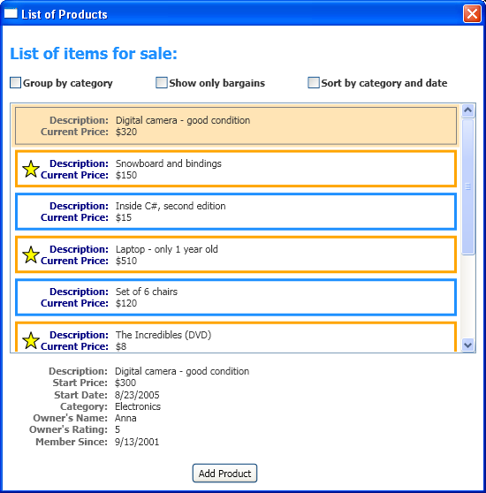

Figure 2.2 – Master-Detail scenario

Task 3 – Add functionality to “Group by category” CheckBox
New concepts: Grouping

- At the end of this task, the user will be able to click the “Group by category” CheckBox on top of the Window and group the items in the ListBox.

- Start by adding the following event handlers to MainWindow.xaml.cs. These handlers allow the user to add and remove grouping on the view:

private void AddGrouping(object sender, RoutedEventArgs args)
{
// This groups by property "Category"
PropertyGroupDescription groupDescription = new PropertyGroupDescription();
groupDescription.PropertyName = "Category";
listingDataView.GroupDescriptions.Add(groupDescription);
}

private void RemoveGrouping(object sender, RoutedEventArgs args)
{
listingDataView.GroupDescriptions.Clear();
}

- Now hook up these event handlers to the Checked and Unchecked events in the Grouping CheckBox in MainWindow.xaml:

<CheckBox Name="Grouping" Grid.Row="1" Grid.Column="0"
Checked="AddGrouping" Unchecked="RemoveGrouping"
Margin="8" Style="{StaticResource checkBoxStyle}">Group by category</CheckBox>

- Finally tell the ListBox which template to use for the header of the groups. Notice that this template is already added to the resources, so we just need to use it.

<ListBox Name="Master" Grid.Row="2" Grid.ColumnSpan="3" Margin="8"
ItemsSource="{Binding Source={StaticResource listingDataView}}" >
<ListBox.GroupStyle>
<GroupStyle
HeaderTemplate="{StaticResource groupingHeaderTemplate}"
/>
</ListBox.GroupStyle>
</ListBox>

- Run your application. Check the “Group by Category” CheckBox and see the items being grouped.

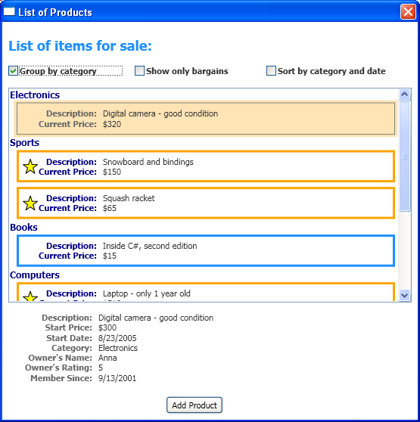

Figure 2.3 – Grouping

Task 4 – Add functionality to “Sort by category and date” CheckBox
New concepts: Sorting

- At the end of this task the user will be able to click the “Sort by category and date” CheckBox on top of the Window and sort the items in the ListBox.

- Add the following event handlers to MainWindow.xaml.cs. Notice that we are sorting by two properties in this scenario: first by Category, then by StartDate.

private void AddSorting(object sender, RoutedEventArgs args)
{
// This sorts the items first by Category and within each Category, by StartDate
// Notice that because Category is an enumeration, the order of the items is the same as in the
// enumeration declaration
listingDataView.SortDescriptions.Add(new SortDescription("Category", ListSortDirection.Ascending));
listingDataView.SortDescriptions.Add(new SortDescription("StartDate", ListSortDirection.Ascending));
}

private void RemoveSorting(object sender, RoutedEventArgs args)
{
listingDataView.SortDescriptions.Clear();
}

- Hook up the event handlers to the interface in MainWindow.xaml:

<CheckBox Name="Sorting" Grid.Row="1" Grid.Column="3"
Checked="AddSorting" Unchecked="RemoveSorting"
Margin="8" Style="{StaticResource checkBoxStyle}">Sort by category and date
</CheckBox>

- Run the project. Check the “Sort by category and date” CheckBox and see how the order of the items changes. Grouping and sorting at the same time will cause the group names to be sorted alphabetically (since we are sorting first by Category) and the items within those groups to be sorted by StartDate.

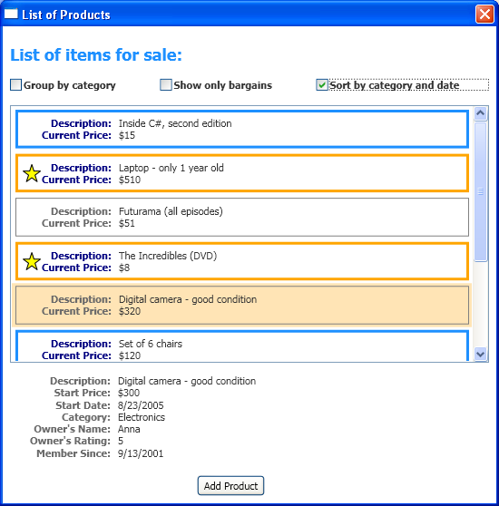

Figure 2.4 – Sorting

Task 5 – Add functionality to “Show only bargains” CheckBox
New concepts: Filtering

- At the end of this task the user will be able to click the “Show only bargains” CheckBox on top of the Window and filter out the items that cost $25 or more.

- Add the following event handlers to MainWindow.xaml.cs. Notice the ShowOnlyBargainsFilter event handler that filters out expensive items.

private void AddFiltering(object sender, RoutedEventArgs args)
{
listingDataView.Filter += new FilterEventHandler(ShowOnlyBargainsFilter);
}

private void RemoveFiltering(object sender, RoutedEventArgs args)
{
listingDataView.Filter -= new FilterEventHandler(ShowOnlyBargainsFilter);
}

- Link the handlers to the appropriate events in MainWindow.xaml:

<CheckBox Name="Filtering" Grid.Row="1" Grid.Column="1"
Checked="AddFiltering" Unchecked="RemoveFiltering"
Margin="8" Style="{StaticResource checkBoxStyle}">Show only bargains</CheckBox>

- Run the application. Checking the “Show only bargains” CheckBox will leave in the ListBox only those items priced lower than $25.

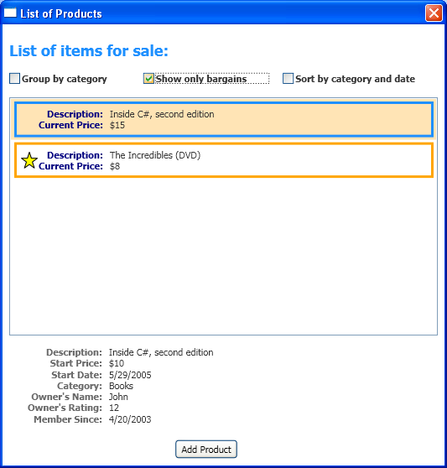

Figure 2.5 – Filtering

Task 6 – Link the two exercises together.
- The goal of this task is to allow the user to add an item to the collection by using the entry form completed in the first exercise, then view it together with the other items in the master-detail scenario of the second exercise.

- Add the following event handler to MainWindow.xaml.cs. This opens the entry form Window created in the first exercise.

private void OpenAddProductWindow(object sender, RoutedEventArgs e)
{
AddProductWindow addProductWindow = new AddProductWindow();
addProductWindow.ShowDialog();
}

- Now link that to the Click event of the “Add Product” Button in MainWindow.xaml:

<Button Name="OpenAddProduct" Grid.Row="4" Grid.Column="1" Content="Add Product"
HorizontalAlignment="Center" Margin="8"
Click="OpenAddProductWindow"
/>

- Add the following code to AddProductWindow.xaml.cs which adds the item created to the collection of items. Notice the AuctionItems collection in DataBindingLabApp.xaml.cs.

private void SubmitProduct(object sender, RoutedEventArgs e)
{
AuctionItem item = (AuctionItem)(this.DataContext);
((DataBindingLabApp)Application.Current).AuctionItems.Add(item);
this.Close();
}

- Run the application. You should now be able to click the “Add Product” button to navigate to the entry form Window. After pressing “Submit” in the entry form Window, you will be able to see the item just entered in the ListBox.

Lab Summary
In this lab you performed the following exercises:

- Allow user to enter an item for sale
- Allow user to view list of items for sale

You became familiar with the Binding object, and learned that a MultiBinding can be used to bind to more than one property in the data source.

You saw how to add Validation to your controls and how easy it is to change the way the user gets notification of an error.

You added custom logic to your bindings by using Converters and learned how to control property change notifications that cause the bindings to be refreshed.

You understood the Master-Detail scenario and used CollectionViewSource to add grouping, sorting and filtering to a data-bound list of items.

And while learning all this, you coded an auction application that allows the user to enter a new item for sale, preview its appearance, add it to a list of items and look at a desired item’s details by selecting that item.

Hopefully you enjoyed learning the Data Binding concepts in this lab. The next step is taking these ideas and applying them to your own projects. Good luck!

